**PREDICTING THE PROGRESSION OF HEART DISEASE USING MCMC**

Erik Nylander, Tulasi Ramarao, Youqing Xiang | IS604 | Spring 2016

**Abstract**

Close to six hundred thousand people die of heart disease every year in the U.S which equates to 1 out of every 4 deaths in the country. The lowest death rates were in the Western United States and highest rates were in the Southern United States [Fig 1]. Given the prevalence of heart disease, several tools are now available online to predict the prognosis of a patient once one of several risk factors like high cholesterol and high blood pressure develop. In this paper, a Monte Carlo simulation model is designed to look at possible scenarios to slowdown the progression of this deadly disease.





**1 in 4 deaths is due to heart disease in the US**

***Fig 1****: Results as posted on cdc.gov*

**Keywords:** Cardiovascular disease, Markov Chain Monte Carlo, Diagnosis, Simulation, Intervention.

**Introduction and Literature Review**

If heart disease is detected at an earlier stage, a treatment regime can not only slow the progression of this disease, but can also help to reduce the medical costs associated with the treatment of this disease in its later stages. Also, if this diagnosis can be automated based on test results then it is easier to diagnose patients in an earlier stage of the disease which allows for a longer and higher quality life for the patient. Several research papers were used to explore these ideas and the topics of early detection and intervention. The authors of *India Heart Disease Diagnosis Using Predictive Data* [Ref# 1] used decision trees and Naïve Bayes methods to develop a system to diagnose and predict heart disease and the authors of *Cost-of-illness Study of Type 2 Diabetes Mellitus in Colombia* [Ref #2] used Markov Transition model to determine the overall as well as per patient cost of illness due to Type 2 Diabetes. In this paper, both of the methods developed in these papers will be combined to predict a patient’s progression through heart disease and analyze the effect of interventions at various stages in the progression of the disease.

**Methodology**

In this paper, a Markov Chain Monte Carlo (MCMC) model [Fig 6] was developed to simulate the progression of heart disease by using cardiovascular disease risk factors downloaded from the UCI Machine Learning Repository: Heart Disease Data Set [Ref # 7]. This data was wrangled and then modified to add a Time series column to facilitate fitting the data to a Monte Carlo Simulation model.

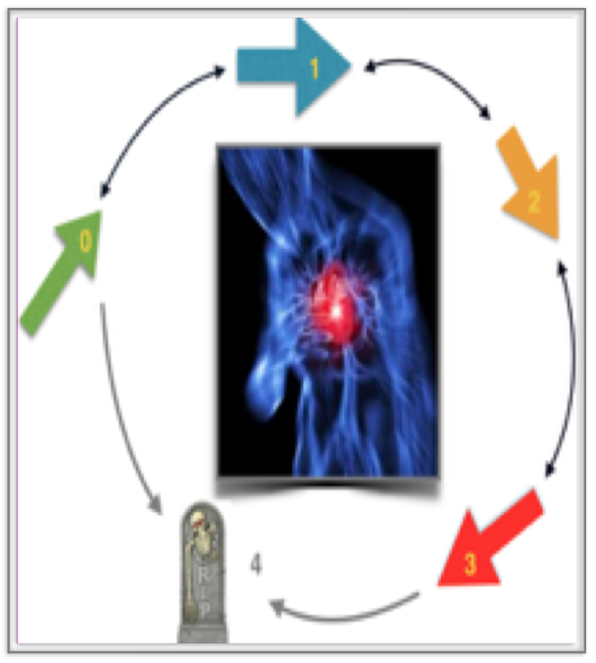

The MCMC model was created by reducing the description of the disease into a five state model as described by NY Heart Association (NYHA). The five states are listed below and the progression of the disease is as shown in Fig 2.

* State 0: No-heart disease
* State 1: Mild
* State 2: Moderate
* State 3: Severe
* State 4: Death

**Fig 2:** Stages in the progression of heart disease

The Heart Disease dataset contained information on symptoms, risk factors and the Disease State of the patient. The MCMC model [Fig 3] was then used to predict events that occur within the data at fixed intervals. The flow diagram above shows the flow of a patient through the model and is described probabilistically as a set of transitions among the states in fixed duration (per year).The likelihood of making a transition from one state to the next is defined as a set of transition probabilities. Effects of an intervention will be assessed mathematically by adjusting the transition probabilities among the states. These interventions will be implementing by increasing the probability of an individual staying in their current Disease State or increasing the probability that a patient will move to a less severe disease state. Effects of an intervention will be assessed mathematically by adjusting the transition probabilities among the states.

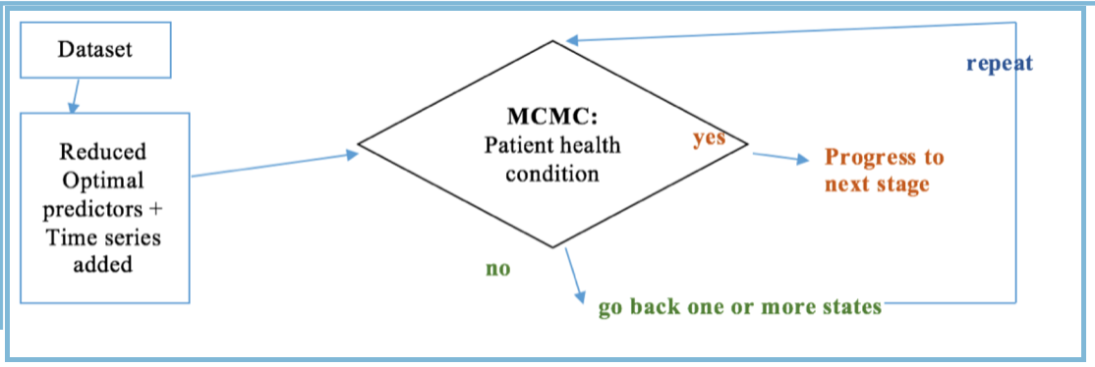

**Fig 3:** *Flow Diagram of the simulation process*

*Assumptions:*

A patient in this MCMC model is always in one of five discrete states called Markov states. The events in this model are represented by transitions from one state to the other. As patients progress through the simulation from a healthy state to the onset of heart disease and to death, they can develop symptoms that lead to more and more complications represented by each of the Disease States. A patient can belong to 2 or more states in real life, but for simplicity sake, this scenario is not considered in this model. Also, the assumption is that all patients enter the simulation at Disease State 0. It is possible that a person is not diagnosed until at a much later disease state, however watching the progression of a patient through the entire disease process proved be more interesting in the primary analysis.A patient can advance from state 1 to any of the other Disease States as long as the patient is alive. A patient can advance to State 4, death, from any state. Patients can also move from a lower state to a much higher state, for example - from state 1 to state 3.

*MCMC steps:*

Some of the steps implemented to develop the Markov model were:

1. Construct a decision tree

Enumerate the possible states

Define the allowable state transitions

1. Identify the probabilities

Associate the probabilities with the transitions

Identify the cycle length and the number of cycles

Identify an initial distribution of patients within the states

1. Identify the outcome values
2. Calculate the expected value

The data description is as shown in [Table 2] in the Appendix. The attribute called *num* was used as a response variable and its value range was from 0 to 4 indicating the states of the heart disease.

*Decision tree for the Heart Disease:*

Fig. 4 shows the logic used for the decisions - with and without intervention.

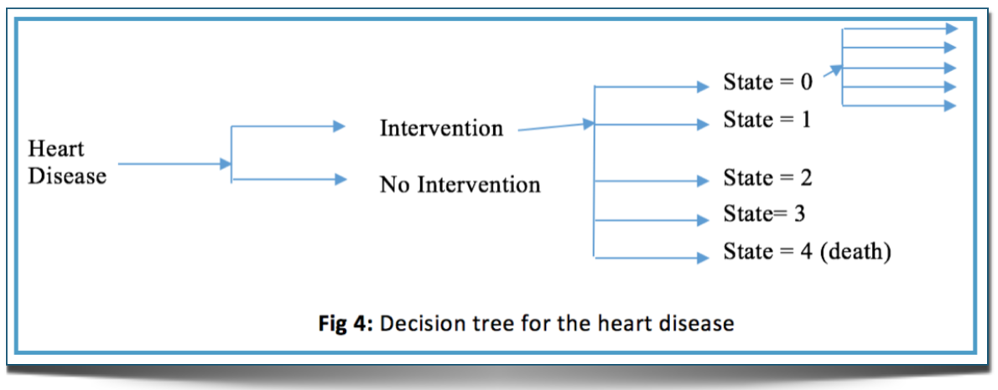

*Associating probabilities with the transitions:*

Cleveland dataset was used to analyze the distribution of these States. There were 164 patients classified as State 0 (no heart disease), 55 as State 1, 36 as State 2, 35 as State 3 and 13 as State 4(dead).

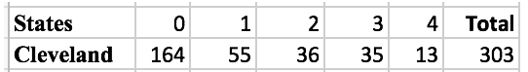

Next, the transition probabilities were assigned arbitrarily and adjusted [Ref# 4].

*Data for the following year were assigned these values:*

* State 0 transition probabilities:(total-164):

105 spent in State 0, 59 in State 1, none in State 2-4

* State 1 transition probabilities:(total-55):

8 spent in State 0, 35 in State 1, 10 in State 2, 2 died.

* State 2 transition probabilities:(total-36):

0 spent in State 0, 9 in State 1, 15 in State 2, 10 in State 3, 2 died

* State 3 transition probabilities:(total-35):

0 spent in State 0, 0 in State 1, 10 in State 2, 20 in State 3, 5 died

* State 4 transition probabilities: (total-13):

0 spent in State 0, 0 in State 1, 0 in State 2, 0 in State 3, 13 State 4(died)

This data was then converted into a transition table [Table 1].

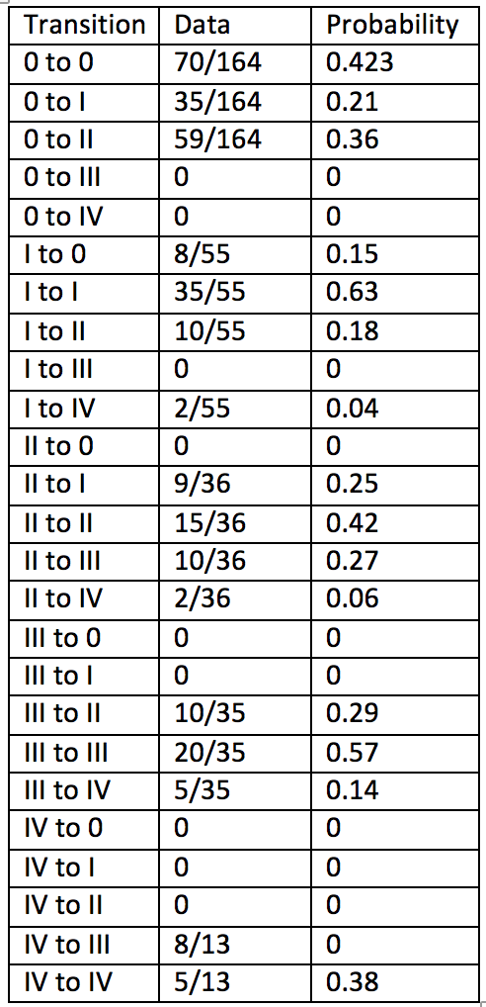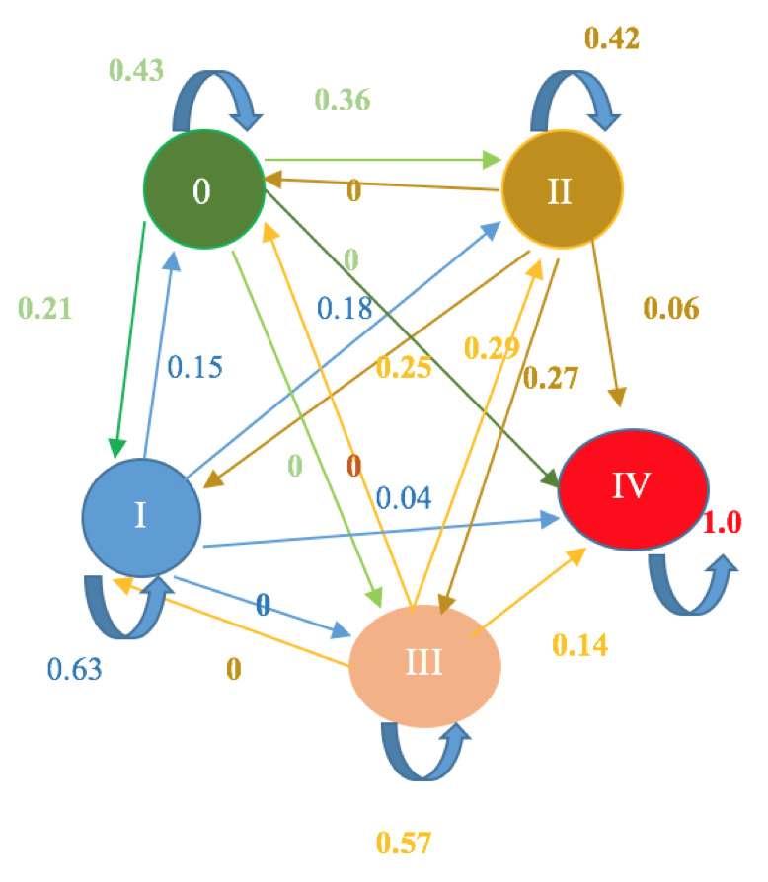

***Fig 6:*** *Markov model (Heart Disease Model)*

***Table 1:*** *Probability Transition Table*

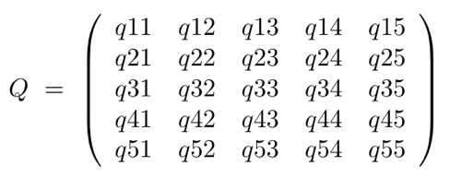

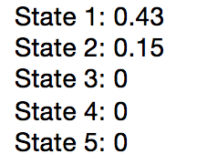

**Fig 7a**: Initial distribution

**7b**: General model for disease

*Initial Distribution:*

An arbitrary initial distribution [Fig 7a] was assigned to start the Simulation process. To fit the data, a multistate model with a transition intensity matrix Q was defined as shown [Fig 7b and Fig 7c]

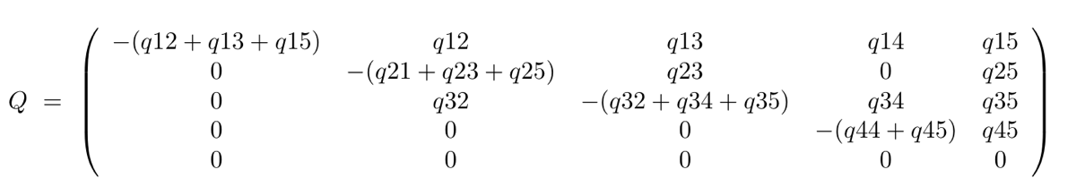

***Fig 7c:*** *Matrix 2*

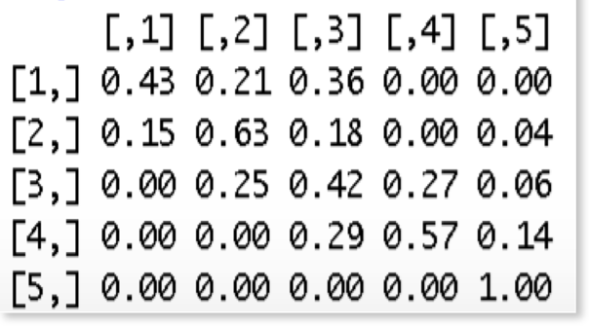

Then a matrix of the same size as in Fig 7b was defined, with zeroes in corresponding positions of zeroes in Fig 7c. The other positions had their initial values filled from the probability Transition table [Fig 3]. This matrix was then used in the qmatrix when calling the R-MSM function. So, finding the unknown values represented in the matrix (the non-zero values) would result in fitting the model.

***Fig 7d:*** *Matrix 3*

To find the true maximum likelihood estimates, the model was run repeatedly using the initial values. To define allowed transitions in this model, a matrix which had the same size as Q was defined. Since there were not many changes between the observation times, this crude method worked [Fig 10] [Ref#: 5]

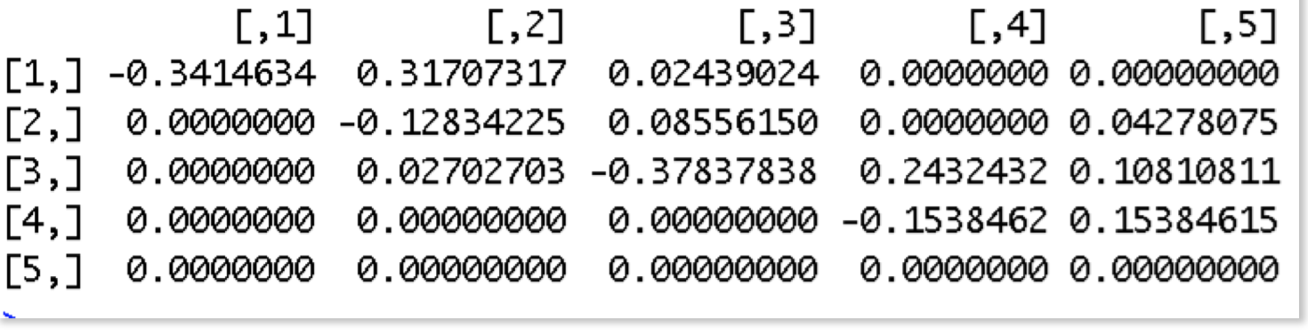

***Fig 10:*** *Matrix 4*

**Results and experimentation**

A fitted model object called MSM in R was used along with the dataset [Ref # 6], the transition matrix Q[Ref # 4],and the initial values set as its parameters [Fig 7a].

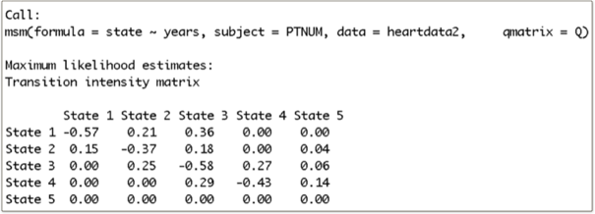

***Fig 11:*** *Resulting model by using the msm function call in R*

The output from the MSM call [Fig 11]showed that the patients were more likely to die with symptoms than without symptoms. For example, without symptoms meant a direct transition from State 1 to State 5. Once the disease was onset, the transition from State 2 to State 3 was more likely (0.18) than staying at State 2(0.-37). Once in State 4 (with severe heart disease), it was highly unlikely (-0.43) to stay in that state. Patient spent a mean of 2.32 years (-1/0.43) in State 4 before death or even recovery.

*Transition probability Matrices:*

A function called pmatrix helped in analyzing the transition probability for 10 years of time.

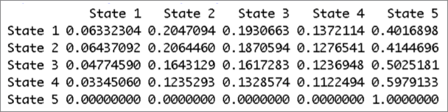

***Fig 12:*** *Output from the pmatrix function*

It can be seen from the pmatrix output[Fig 12] that a person without heart disease has a probability of

0.40 of dying in 10 years from today,

0.06 of staying without heart problems,

0.2 of getting into a slightly mild state of disease,

0.19 of getting into a mild state of disease,

0.13 of getting into a serious state of this disease.

*Probability of the next state:*

This information showed how the Markov model worked. This gave a more intuitive view of a continuous-time Markov model rather than the transition matrix we saw earlier. This matrix gave the mean of sojourn times. The mean sojourn times is the average time in a single stay and forecasts the the total time before the death in other

states.

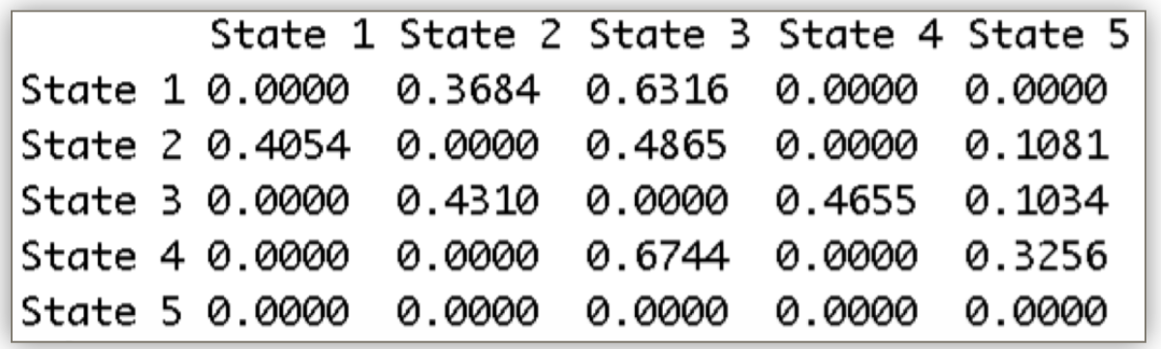

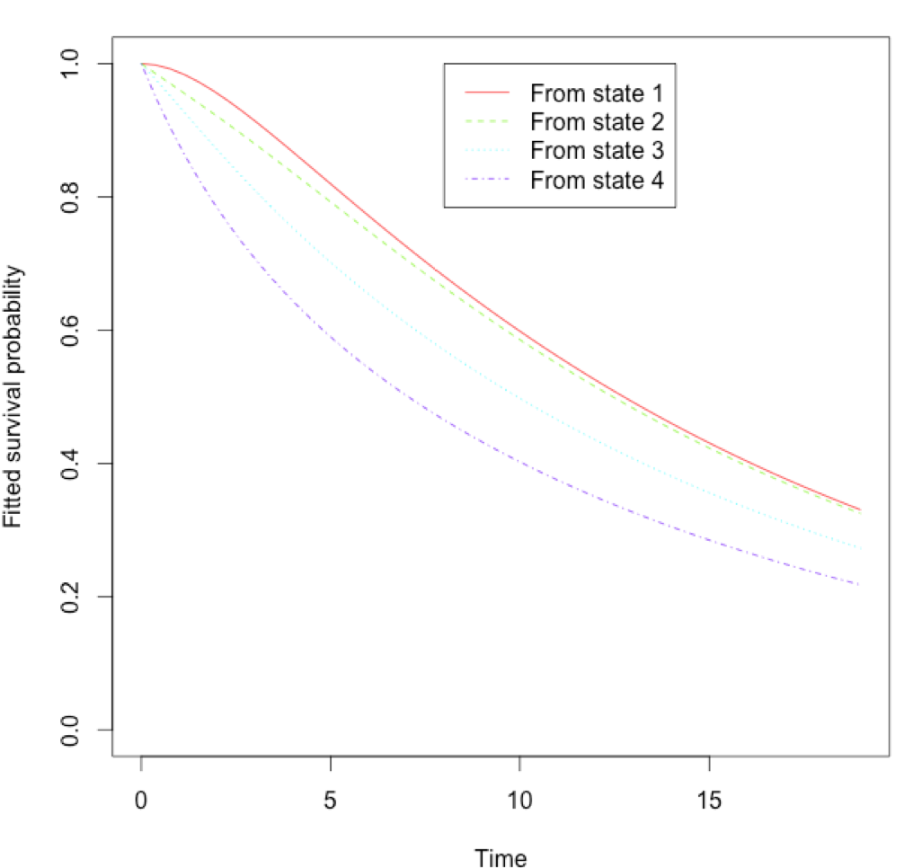

The total length of stay is given below. The R function call called totlos.msm estimates the total length of time spent in each transient state between State 1 and State 5. This is calculated by the following formula, where r represents the begin state (State 1).

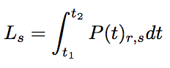

**Fig 13:** Plot for survival probability of different states

The output from the R function call totlos.msm:



These results showed that each patient could be expected to spend

3.17 years in State 1, 5.4 years in State 2, 5.3 years in State 3 and 3.3 years in State 4.

**Survival probability:**

When the expected(probability) of survival against time was plotted [Fig 13] for each of these states, then the plot showed that a 10 year (survival) probability was near to 0.2 for State 3, close to 0.3 for state 2 and close to 0.4 for state 1.

**Simulation:**

After analyzing the Markov Chain Monte Carlo simulation for heart disease in R, a simulation was created that showed the progression of heart disease in the Simio software. Screenshots of the model as well as the results are shown in the Appendix. To simulate this system in Simio, the following procedure was followed:

* Patients were created and placed in State 0.
* These patients then selected a path back to State 0 or to other States in the system based on the transition probability from the transition matrix that was developed above.
* Then patients and the paths were designed in such a way that it took a single day for the patients to travel their assigned paths.

This enabled the creation of one simulation that had transitions that occurred every one unit of time. The servers in the model had an infinite capacity so that patients could then transition at the end of each unit of time to a State of the disease. Once a patient transitioned to State 4, the patients were removed from the simulation.

The Simio simulation proved to be a very natural way to experiment with the model and the experiments of introducing different interventions were conducted by changing the probability of patients selecting a given path. For this Simio simulation, attention was given to the self-return pathway at different stages, such as S0 to S0, S1 to S1, S2 to S2 and S3 to S3. The other pathways were kept at their initial link weights, and then the probability of self-return pathway was gradually increased by increasing the link weight. First, the experiment was run by changing the probability of the self-return pathway at each stage separately and then later changing at all four stages together. By doing so, the outcomes for self-return pathway intervention at different stages were observed; and the potential difference between the individual stage intervention as well as the multiple stages intervention was evaluated. The details on the Simio simulation setup is shown in the Appendix.

*Results from the Simulation:*

The Simulation was constructed to measure the effects of intervention on the number of deaths from heart disease. Given this functionality, the model needed to be validated that the simulation was calculating an appropriate number for the average number of deaths due to heart disease. From the analysis of the Markov Chain Monte Carlo simulation above [Fig 13], the expected number of patients with heart disease to have reached Stage 4 after a 10-year period was about 40%. To validate the simulation against this finding, an experiment was constructed to run the simulation 30 times and the mean and standard deviation for the number of individuals reaching Stage 4 was calculated. A statistical test was then constructed to determine if these results were consistent with the MCMC model.

The experiment function in the Simio software resulted in the following observations:

A hypothesis test was then constructed at an α = 0.05 level:

These two values were then used to calculate the t-statistic as follows:

The p-value associated with this test statistic was calculated to be 0.051. While this result was in the borderline, there was not enough evidence to reject the null hypothesis and hence was concluded that this simulation gave a reasonable approximation for the number of deaths after 10 years. While not an ideal p-value, the decision was to move forward with this simulation to experiment on the effects of interventions at different stages of the disease.

A total of 16 runs were performed for the experimentation on different interventions at each disease state and the results are as shown in the following plots [Fig 14].

These plots show that:

1. Increasing the probability of self-return pathway at each stage decreases the number of entities entering stage 4.
2. Comparing the stages showed that state 0 and state 2 decrease more with the number of entities entering stage 4(after the probabilities of self-return pathway are set to the same).
3. Increasing the probability of self-return pathway at four stages together also decreases the number of entities entering stage 4.

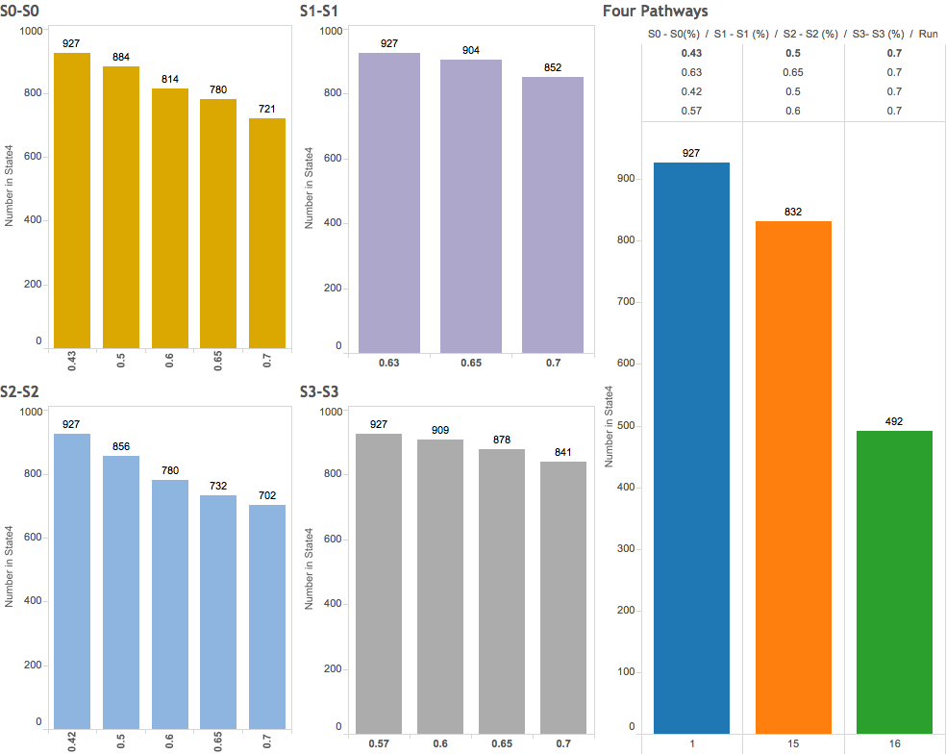

***Fig 14:*** *Plots using intervention (created using Tableau in Excel)*

*Discussion of the outcome:*

Certain observations made from the outcome of the results are listed below:

* Stage 0 and Stage 2 self-return pathways are very effective for heart disease prevention.
* For Stage 0 (besides as the initial stage) has more room to increase its probability and then prevent the progress of heart disease since the initial probability for S0-S0 pathway is very low (0.43).
* For Stage 2, similar to Stage 1, initial probability for S2–S2 pathway is also low (0.42).
* Meanwhile, S2-S1 pathway initial probability is 0.25. Although going back to previous stage pathways was not investigated separately, relatively high S2-S1 pathway probability and low S2-S2 pathway probability at initial stage makes stage 2 a good target for disease prevention.
* Besides having Stage 0 and Stage 1 as good targeting stages, the simulation results also suggest that multiple pathways intervention is much more effective way for heart disease prevention than any individual pathway intervention.

*Challenges:*

There were several challenges in this project. Heart patient datasets with time-series was not available, so the UCI dataset had to be wrangled extensively before it could be used. The implementation of the simulation was easier in R than Simio, since the project involved Monte Carlo Simulation. However, Simio had a better interface to view the progress of patients through the transitions.

**Summary and future improvements**

This model could be improved in terms of consistency and efficiency. Also, weights and costs could be associated with each symptom and that would make this model more realistic.

**References**

1. Issn (Online) : 2319 - 8753, and Issn (Print) : 2347 - 6710. *K.L.N. College of Engineering, Madurai, Tamil Nadu, India Heart Disease Diagnosis Using Predictive Data Mining* (n.d.): n. pag. Web
2. "Cost-of-illness Study of Type 2 Diabetes Mellitus in Colombia." *Cost-of-illness Study of Type 2 Diabetes Mellitus in Colombia*. N.p., n.d. Web. 05 May 2016.
3. 550, Epi, and 2012 March 2. *Introduction to Markov Models (part 1)* (n.d.): n. pag. Web.
4. "Risk Assessment Tool for Estimating Your 10-year Risk of Having a Heart Attack." *10-year CVD Risk Calculator ( Version)*. N.p., n.d. Web. 16 May 2016.
5. "A Discrete Time Markov Chain (DTMC) SIR Model in R." *Rbloggers*. N.p., n.d. Web. 14 May 2016.
6. Abstract. *Multi-state Modelling with R: The Msm Package* (n.d.): n. pag. Web.
7. "UCI Machine Learning Repository: Heart Disease Data Set." *UCI Machine Learning Repository: Heart Disease Data Set*. N.p., n.d. Web. 16 May 2016.

(Cleveland.csv) [ Missing Attribute Values in the dataset: Several – replaced w/ zeroes.

**APPENDIX:**

**Table 2:** Data description

|  |  |  |
| --- | --- | --- |
| **Attribute** | **Range** | **Attribute name** |
| Age | [29-77] | Age |
| Sex | [0,1] | Sex |
| Resting blood pressure |  | Trestbps |
| Cholesterol | [126,564] | Chol |
| Fasting blood sugar | 1 = true > 120)  0 = false | Fbs |
| Resting electrocardiographic results | 0 – normal  1 – having ST-T abnormality  2 – probable left ventricular hypertrophy | Restecg |
| Maximum heart rate achieved |  | thalach |
| Exercise induced angina | 1=yes, 0 = no | Exang |
| ST depression induced by exercise relative to rest |  | Oldpeak |
| Slope of the peak exercise ST segment | 1 = upsloping  2= flat  3 = downsloping | slope |
| Number of major vessels(0-3) colored by fluoroscopy |  | ca |
| Thal | 3 = normal  6 = fixed defect  7 = reversible defect | thal |
| Diagnosis of heart disease | 0 < 50% diameter narrowing  1 > 50% diameter narrowing | num |

**Snapshot 1:** model simulation using the Simio software

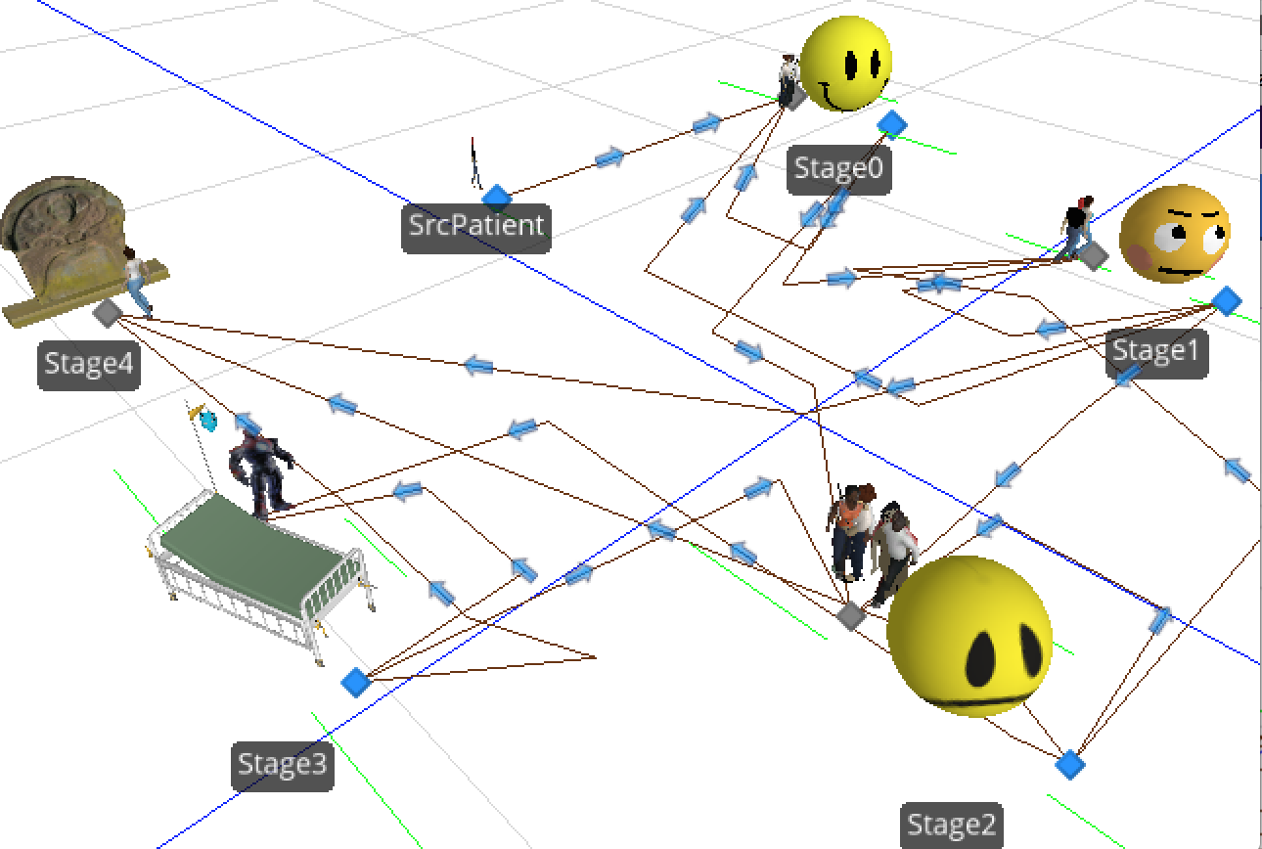

**Snapshot 2:** Results from the simulation model

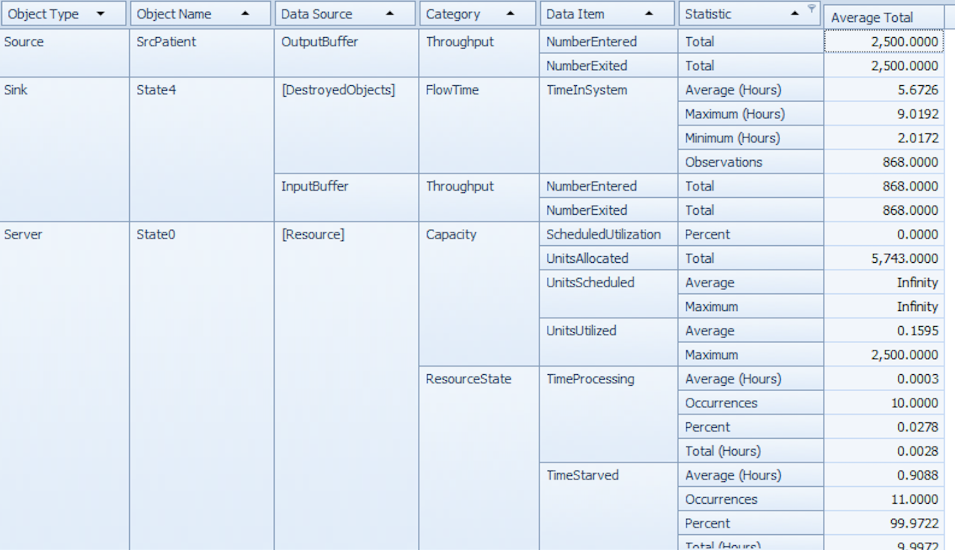

**Snapshot 3:** Setup 1 of 2 from the simulation model

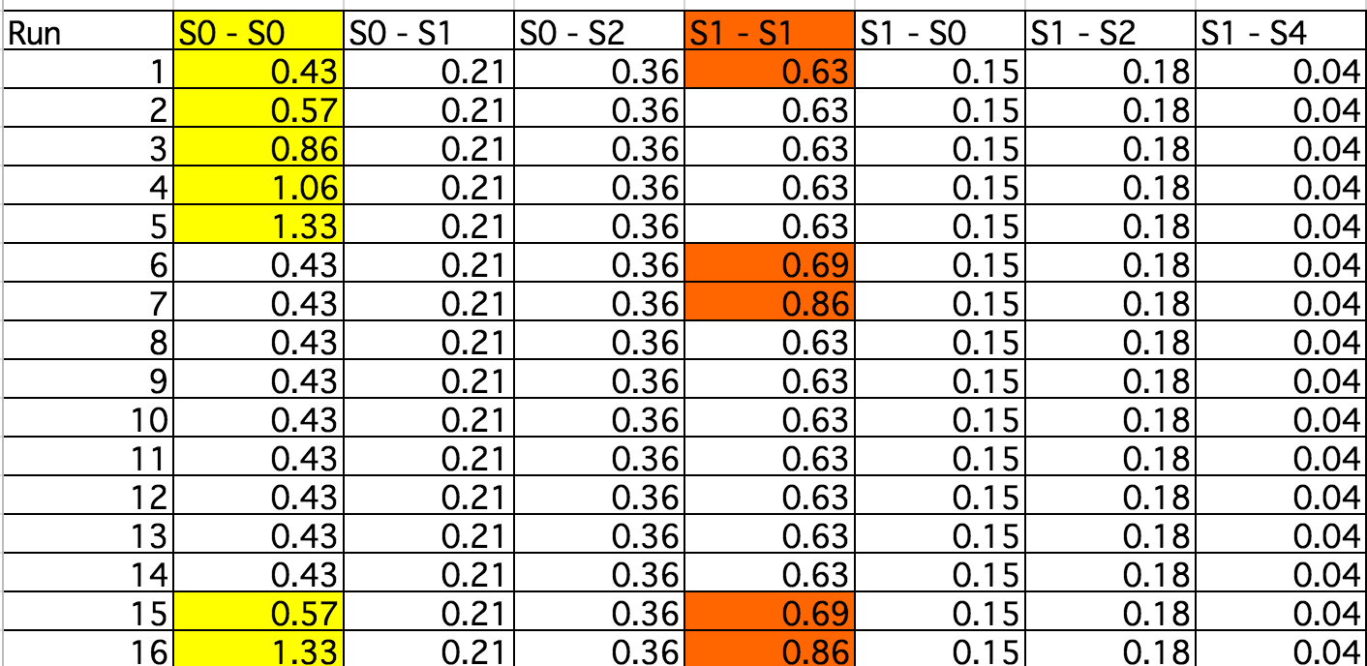

**Snapshot 4:** Setup 2 of 2 from the simulation model

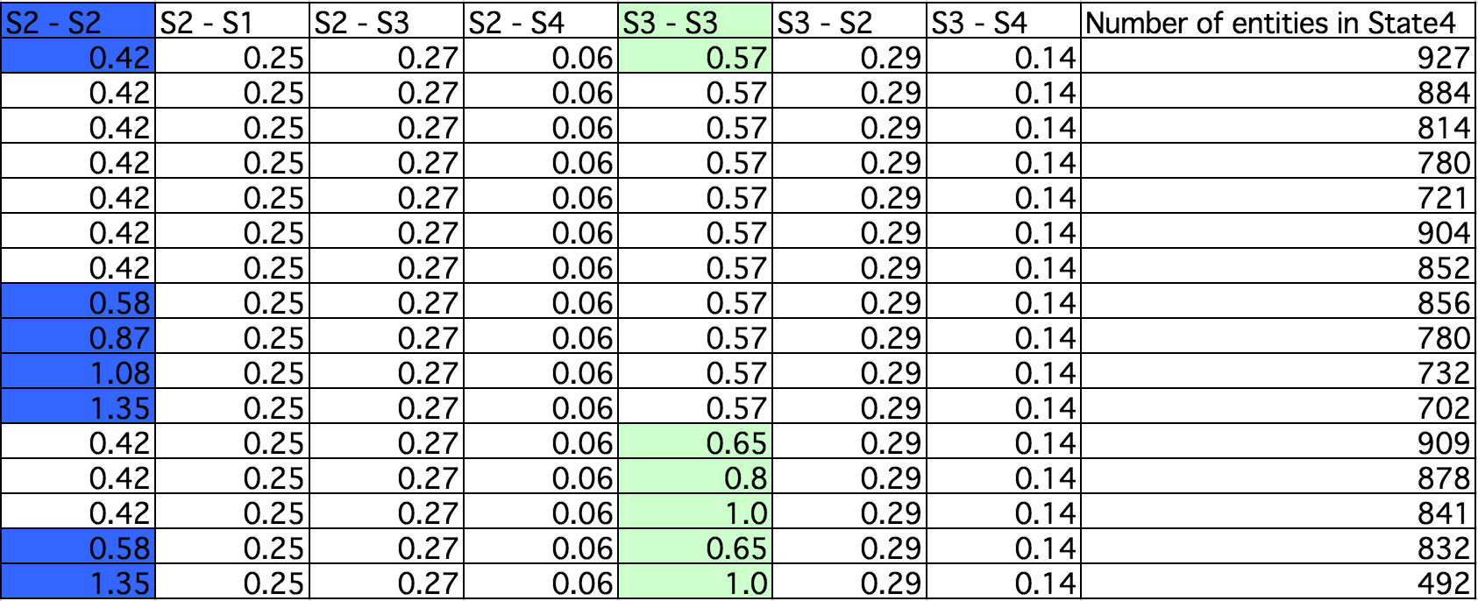

**Snapshot 5:** Final results from the simulation model

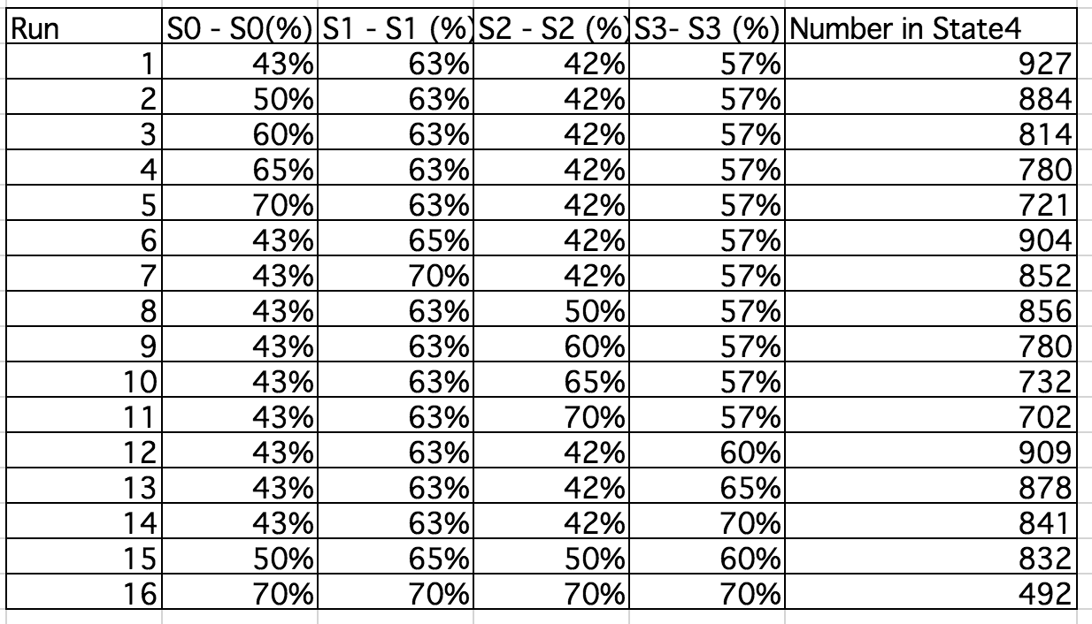

**R Code:**

#Ref# 6

#install.packages("msm")

setwd("/Users/tulasiramarao/Documents/CUNY-SPRING2016/IS604-Simulation/FinalProjectHeart")

# read the patient's heart disease data from the UCI machine repository

pdata <- read.csv("cleveland.csv",header=TRUE, sep=",",stringsAsFactors=FALSE)

# attach the dataset

head(pdata)

nrow(pdata)

attach(pdata)

unique(Num)

require(msm)

head(cav)

print(cav[1:10,])

statetable.msm(state, PTNUM, data=cav)

#write.csv(cav,file="cav.csv")

# get first 303 rows and first 3 columns

predata <-cav[1:303,1:8]

# combine with the patientdata from UCL

newdata <- cbind(predata,pdata)

head(newdata)

#drop columns

df <- subset(newdata, select = -c(Age,dage,Sex,pdiag,cumrej) )

head(df)

df$age <- round(df$age,0)

df$years <- round(df$years,0)

head(df)

df$state[df$state == 1]

write.csv(df,file="heartData.csv")

# manually change heartData.csv to add zero states

# that is ( choose 1s and replace with 0 for state column)

# load that file here

# load the modified data

heartdata2 <- read.csv("heartData2.csv",header=TRUE, sep=",",stringsAsFactors=FALSE)

head(heartdata2,30)

unique(heartdata2$state)

# Now change the states from 0 to 4 to 1 to 5

heartdata2$state[heartdata2$state==0] <- 10

heartdata2$state[heartdata2$state==1] <- 11

heartdata2$state[heartdata2$state==2] <- 12

heartdata2$state[heartdata2$state==3] <- 13

heartdata2$state[heartdata2$state==4] <- 14

heartdata2$state[heartdata2$state==10] <- 1

heartdata2$state[heartdata2$state==11] <- 2

heartdata2$state[heartdata2$state==12] <- 3

heartdata2$state[heartdata2$state==13] <- 4

heartdata2$state[heartdata2$state==14] <- 5

unique(heartdata2$state)

# This is the probability matrix

# Q <- rbind ( c(0.42, 0.21, 0.35, 0, 0),

# + c(0.14, 0.63, 0.18, 0, 0.36),

# + c(0, 0.25, 0.41, 0.27, 0.05),

# + c(0, 0, 0.28,0.57,0.14 ),

# + c(0, 0, 0,0.61,0.38 ))

Q <- rbind ( c(0.43, 0.21, 0.36, 0, 0),

+ c(0.15, 0.63, 0.18, 0, 0.04),

+ c(0, 0.25, 0.42, 0.27, 0.06),

+ c(0, 0, 0.29,0.57,0.14 ),

+ c(0, 0, 0, 0, 1 ))

Q

# Do the simulation using the crude method since there are not many changes between the

# observations

Q.crude <- crudeinits.msm(state ~ years, PTNUM, data=heartdata2, qmatrix=Q)

Q.crude

head(heartdata2,121)

#show the maximum likelihood estimates and 95% confidence intervals

heart.msm <-msm(formula = state ~ years, PTNUM, data = heartdata2, qmatrix = Q, deathexact = 5,method = "BFGS",control = list(fnscale = 4000, maxit = 10000))

heart.msm

printold.msm(heart.msm)

# transition probability matrix

# 10 year transition probability ->

pmatrix.msm(heart.msm,t=10)

# probability that each state is next

pnext.msm(heart.msm)

totlos.msm(heart.msm)

#Survival plots

plot(heart.msm, legend.pos=c(8, 1))